**Alumni-Portal (docs)**

* **Department**
* **Student**
* **Faculty**
* **StudentComment**
* **JobAd**
* **Tag**
* **JobHistory**
* **Logging**

**TO DO:**

**Student, Faculty update - delete fn,ln, email - done**

**JobHistory Implementation+DTO - service impl update, create - done**

**JobApplication Controller - done**

**Aspect Log - done**

**Notification- done**

**Department**

Endpoint URL: [*http://localhost:8080/user/department*](http://localhost:8080/user/department)

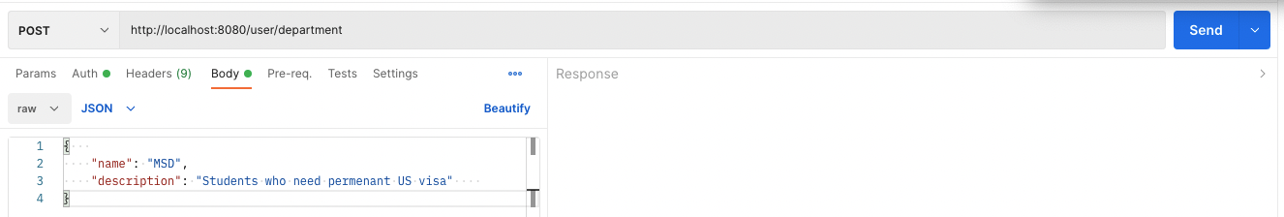

**Student**

Add a student

URL: [*http://localhost:8080/users/student*](http://localhost:8080/users/student)

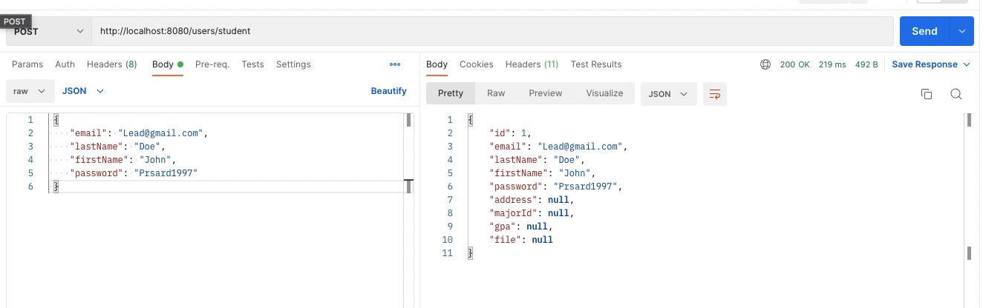

Update a student

URL: [*http://localhost:8080/users/student/{id}*](http://localhost:8080/users/student)

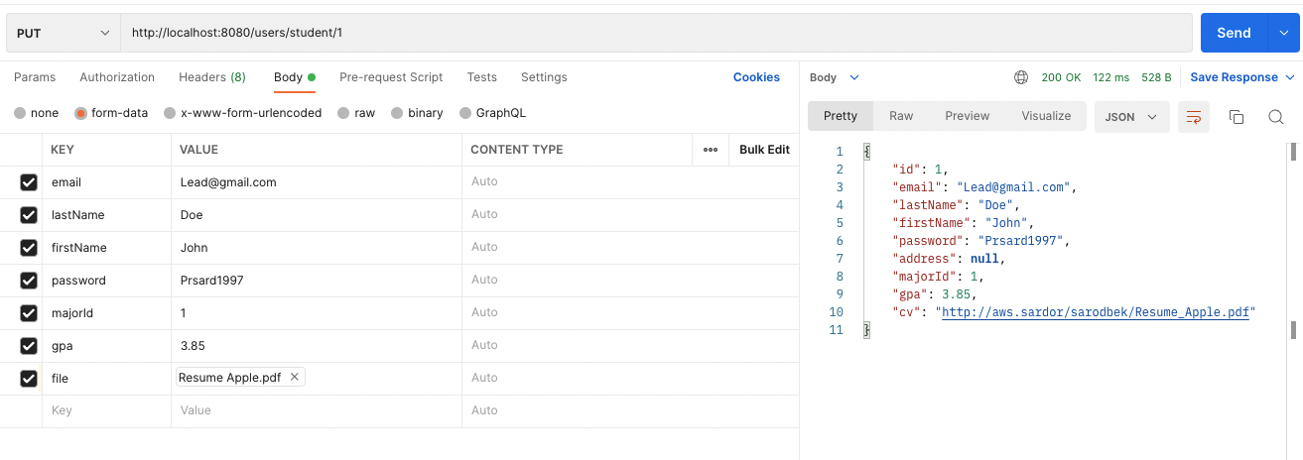

**Faculty**

Add a faculty

URL: [*http://localhost:8080/users/faculty*](http://localhost:8080/users/student)

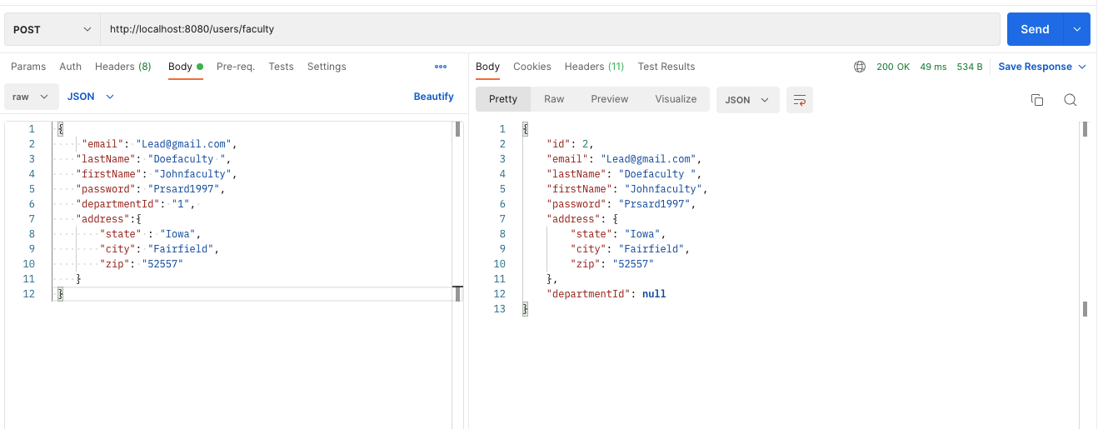

**StudentComment**

Faculty comments to a student

GET URL: [*http://localhost:8080/studentcomment/{studentUsername}*](http://localhost:8080/users/student)

*Get all student comments with student username*

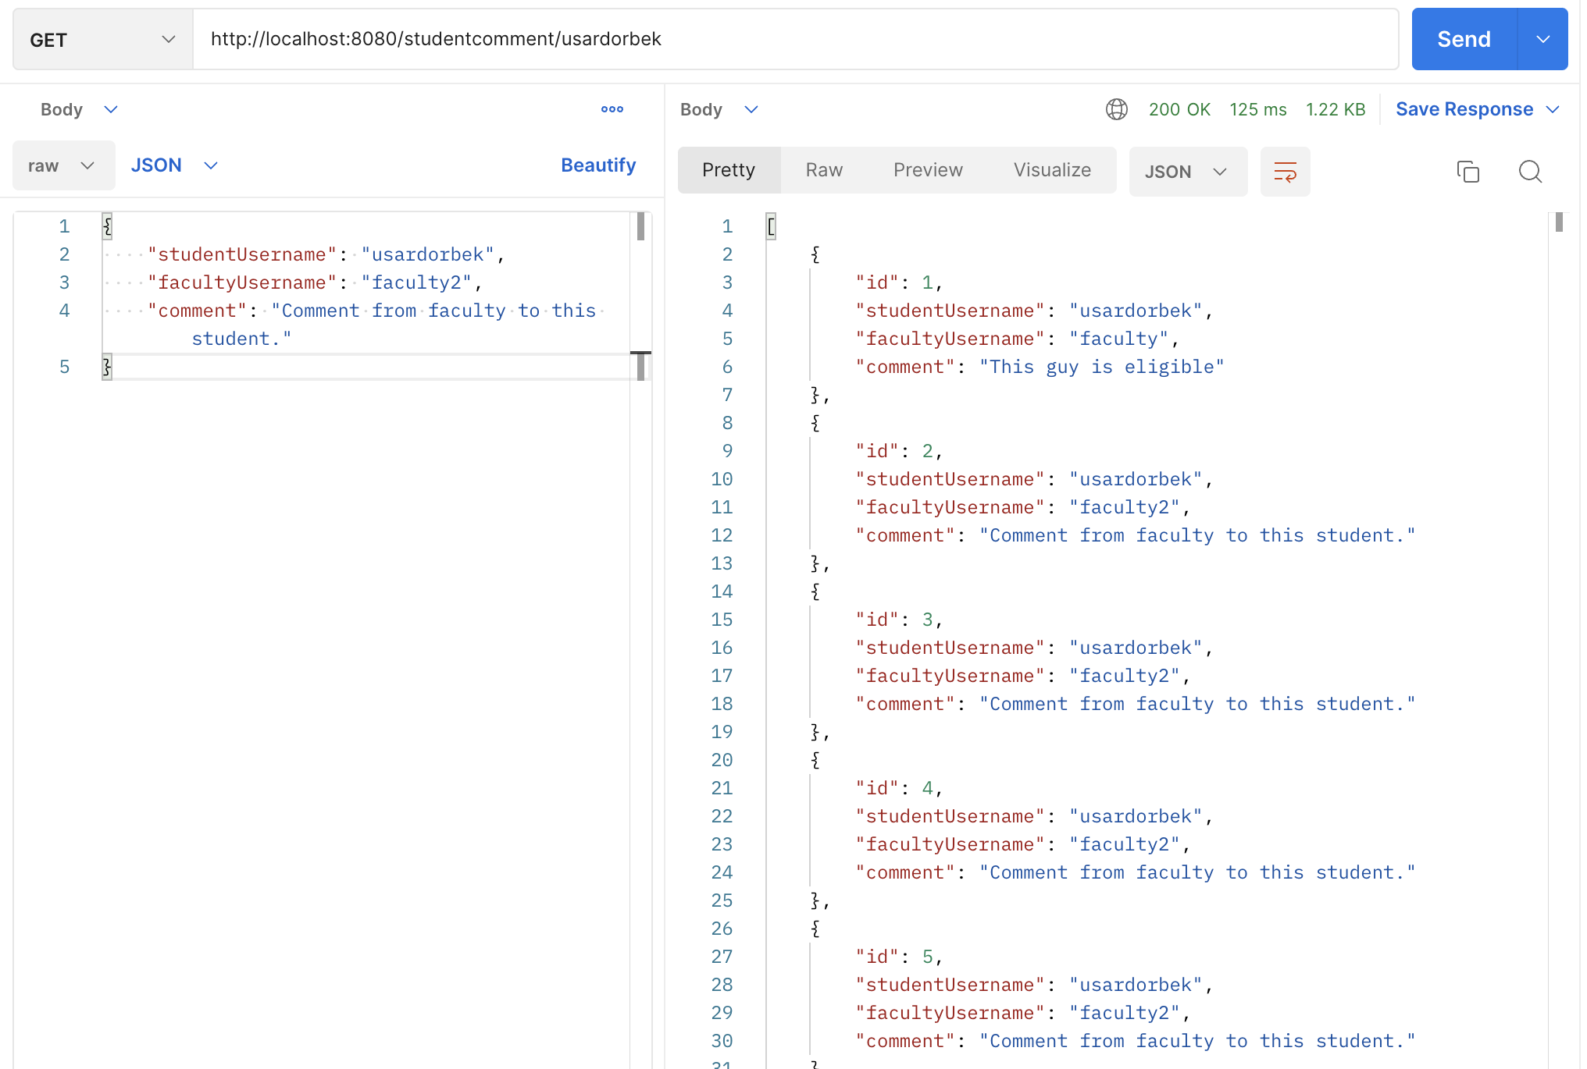

POST URL: [*http://localhost:8080/studentcomment*](http://localhost:8080/users/student)

*Add a comment to a student*

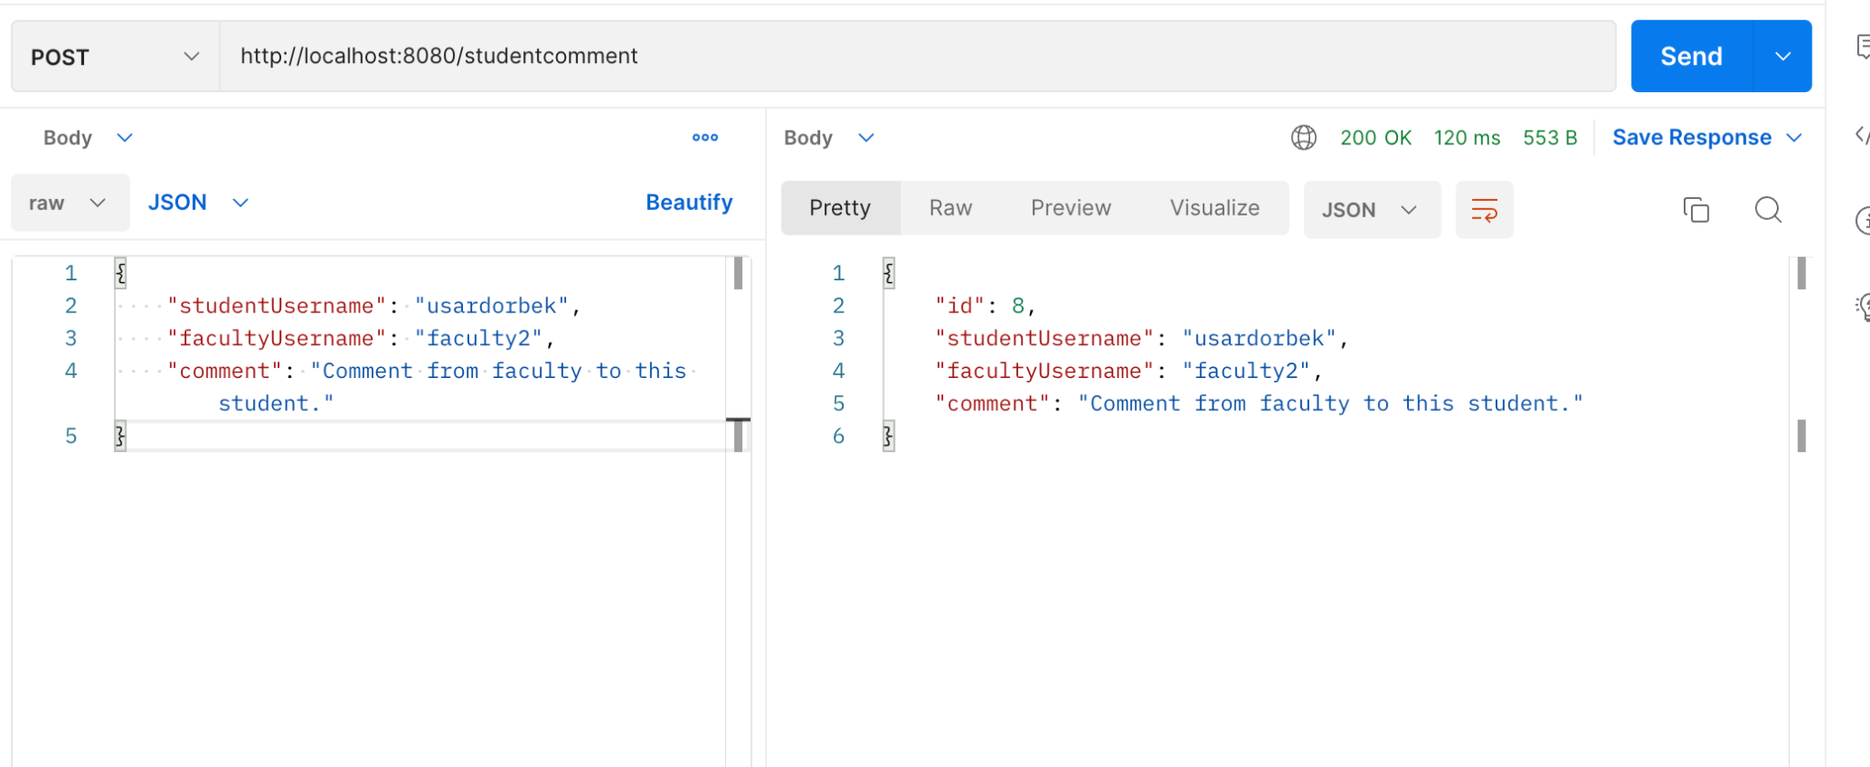

**JobAd**

Add a JobAd

URL: [*http://localhost:8080/jobAd*](http://localhost:8080/users/student)

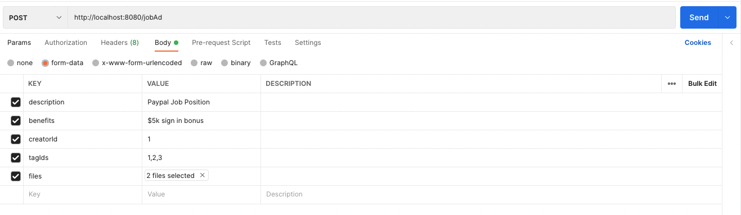

**Tag**

Add a Tag

URL: [*http://localhost:8080/tag*](http://localhost:8080/users/student)

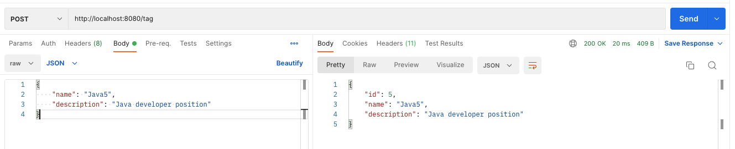

**JobHistory**

Get a JobHistory with username

URL: {GET} [*http://localhost:8080/history/{username}*](http://localhost:8080/users/student)

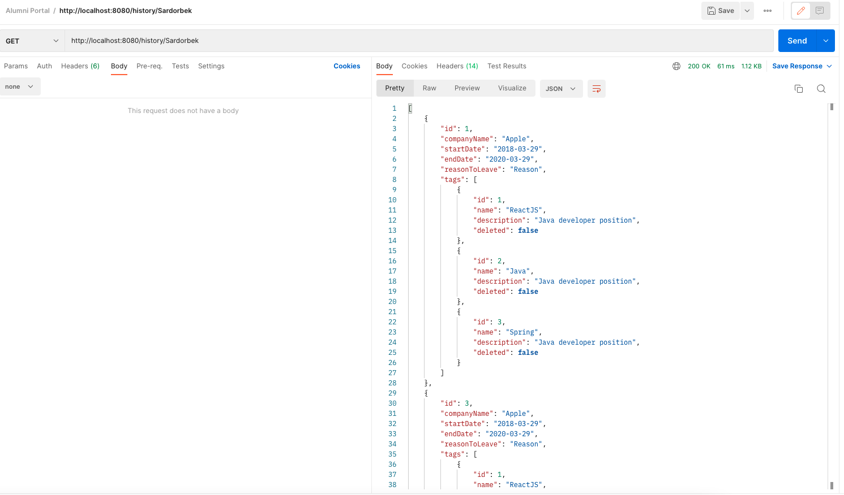

Add a JobHistory with username

URL: “POST” [*http://localhost:8080/history/{username}*](http://localhost:8080/users/student)

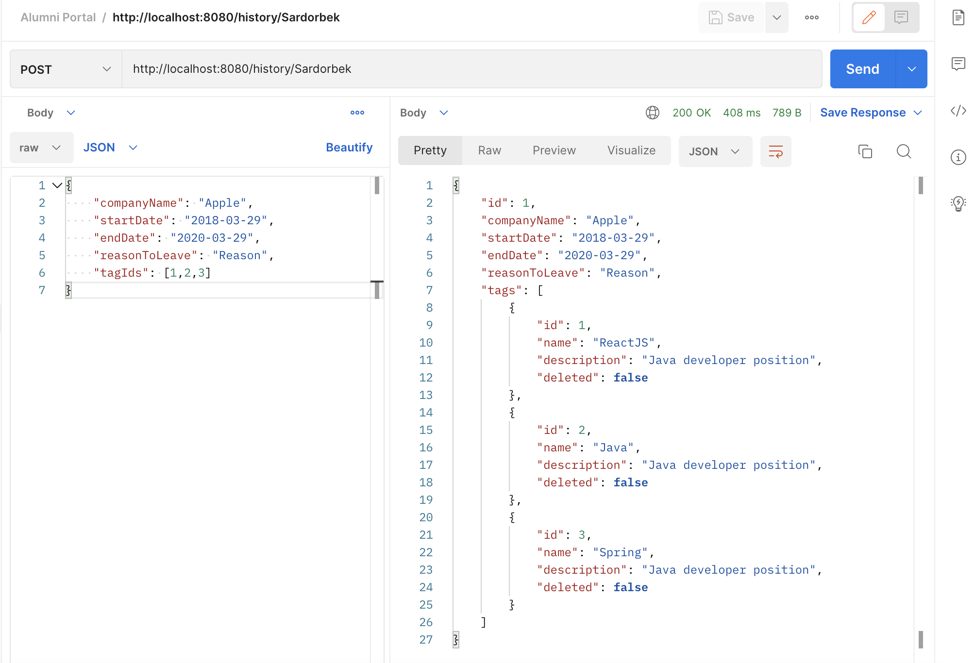

**Logging**

*Aspect => execution time*

*Username is taken from token*

*Log file is saved in directory*

